5.8 I Industrial District
5.8.1 Intent
This district is designed to provide for a wide range of industrial and related uses.

    - Permitted Principal Uses and Structures
The following shall be permitted as uses by right:
- Agriculture, excluding the expansion of existing or the development of commercial livestock facilities/operations;
- Animal care;
- Automobile sales and services;
- Automotive wash facilities;
- Bottling works;
- Building material sales, except for ready-mix concrete plants and similar uses which emit particulate, odor or smoke;
- Carpenter, cabinet, plumbing or sheet metal shops;
- Construction sales and services;
- Dry cleaning and/or laundry plants;
- Electric and telephone substations;
- Farm implementation sales and services;
- Farm produce sales;
- Food service; restaurants, cafes and taverns;
- Freight and truck terminals;
- Garden centers and nurseries;
- Groceries, retail and wholesale;
- Industrial Condos whose individual units meet the requirements of permitted principal uses and structures in Section 5.82.
- Machinery sales;
- Mini-Storage facilities;
- Mobile and modular home sales and manufacturing;
- Newspaper publishing plants;
- Public and quasi-public uses of an educational, recreational, or religious type, including public and parochial elementary schools and junior high schools, high schools; private non-profit schools, churches, parsonages, and other religious institutions; parks and playgrounds;
- Public utility and public service uses;
- Wholesale sales and services;

5.8.3 Permitted Accessory Uses
The following accessory uses and accessory structures shall be permitted:
- Accessory uses and accessory structures normally appurtenant to the permitted uses and special uses shall adhere to Article 8.1 of these regulations. Accessory structures must adhere to 5.8.6 setback requirements.
- Accessory buildings are not permitted in the I Industrial District.

    - Permitted Special Uses
A building or premises may be used for the following purposes in the I Industrial District if a special permit for such has been obtained in accordance with Article 6 of these regulations.
- Junk and salvage yard in accordance with Article 6.3;
- Recycling center in accordance with Article 6.3;
- Ethanol and/or alcohol plants in accordance with Article 3.3 definitions;
- Light, medium, or heavy manufacturing/industrial operations, providing that such use is not noxious by reason of vibration or noise beyond the confines of the building, or by the emission of particulates, fumes, gas odor, or smoke;
- Live Adult Entertainment Establishments, Adult-Oriented Entertainment, or Adult Retail;
- Warehouse, storage houses, transportation warehousing, storage lots;
- Telecommunications towers, when in conformance with the following:
  - Towers shall be located at the most restrictive distance of:
    - The setback requirements in Article 5.8.6
    - a minimum distance of twice the height of the tower from adjacent dwellings or structures other than those associated with the tower facility.
  - Towers shall be a minimum distance from any street, county road, or federal highway of equal to or greater than the height of the tower measured from the right-of-way line.
  - Towers shall have direct frontage on, or direct access to, an improved street, country or township road (not including dirt or minimum maintenance roads).
  - Towers must also comply with the most recent International Building Code, ANSI/TIA provisions, and Federal Aviation Administration requirements.

    - Prohibited Uses and Structures
All other uses and structures that are not specifically permitted or not permissible as special uses shall be prohibited from the Industrial District.

    - Screening
- Where a site adjoins or is located across an alley from the Residential District, a solid wall or solid fence or compact evergreen hedge six (6) feet in height shall be required on the property line common to such districts, except in a required front yard.
- Where a site adjoins or is located across an alley from the Agricultural District, a solid wall or solid fence six (6) feet in height shall be required on the property line common to such districts, except in a required front yard.
- Open storage of materials attendant to a permitted use or special permit use shall be permitted only within an area surrounded or screened by a solid wall or solid fence.
- Screen requirement must be met with the construction of the building.

    - Height and Area Regulations
The maximum height and minimum area regulations shall be as follows:
- General Requirements:
Category | Amount
Minimum lot area | 10,000 square feet
Minimum lot width | 100’
Required front yard | 35’
Minimum Buffer Yard | 20’ when abutting Residential/Agricultural use
Street side yard setback (minimum) | 35’
Required Rear Yard | 45’
Height | 35’
Side Yard Setback (Minimum) | 7’

    - Parking Regulations
Parking within the I Industrial District shall be in conformance the provisions of Article 7 of these regulations.

5.8.9 Corner Lots
- Plantings, structures signs, fences, and walls within the I Industrial District on corner lots shall be in conformance with Article 8.8.7 of these regulations.

5.8.10 Site Lighting
- Site lighting in the I Industrial District shall be conformance with the provisions of Article 8.9 of these regulations.

5.8.11 Storage and Shipping Container Placement and Use Requirements
- It shall be unlawful to place, use, allow, or maintain shipping containers, trailers, or any vehicles within the I Industrial District for storage purposes.
- These restrictions shall not apply to, and no permit shall be required for, the placement of portable storage containers in any zoning district for temporary use for not more than fifteen (15) days out of every 365 days. Persons placing portable storage containers upon their premises shall register such placement with the Village Clerk, noting the date upon which the portable storage containers were first placed upon the premises.
- Licensed contractors may use shipping containers for the temporary location of an office, equipment and/or materials storage during construction which is taking place on the property where the shipping container is located, if the use is authorized pursuant to zoning permit approval authorizing a remodel or construction project on the same site as the temporarily located shipping container.

    - District Diagram

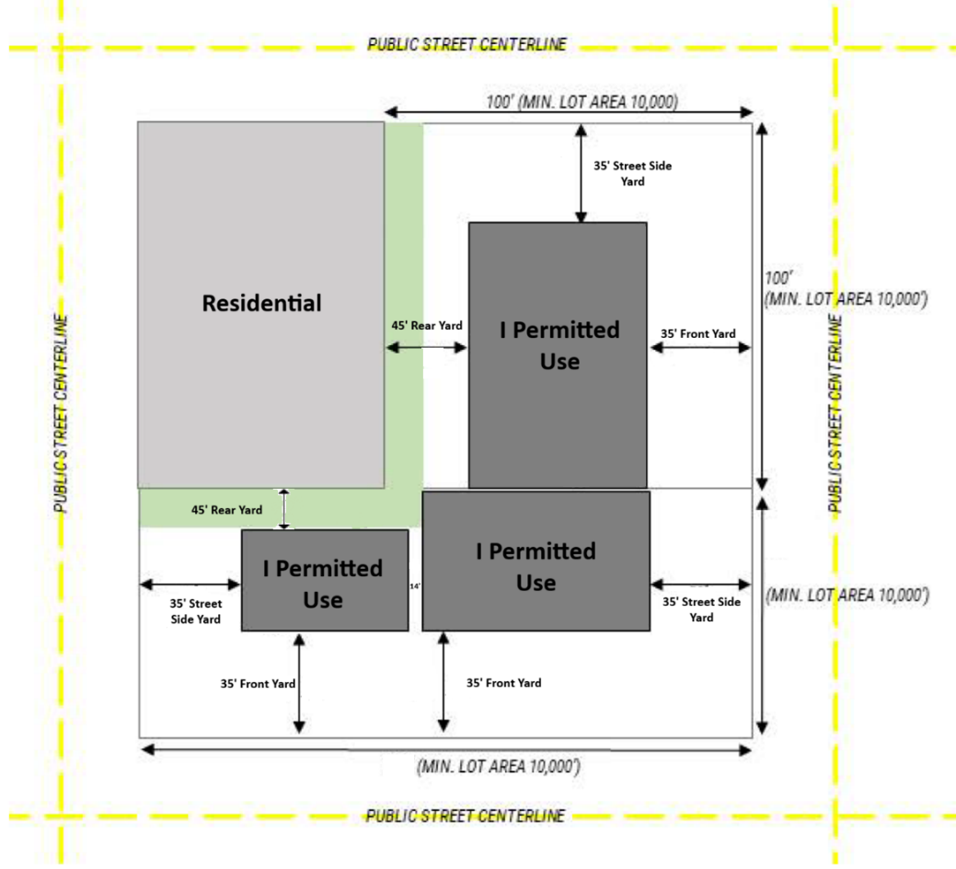
Additional changes to the zoning regulations corresponding to the new Industrial regulations:
- Add to Article 6.3: “Salvage or junk yard operations or recycling centers and related facilities shall only be allowed by special use permit…” Modify the title of Article 6.3 to be “Salvage, Junk Yard, and Recycling Center.”
- Remove all references to hedges from Article 6.3 and Article 6.4.
- Language referencing “Broadcast Towers” in Article 5.1.4 shall be updated to match the updated definitions and use in this article and Article 3.3.
- Create Article 8.10: Outdoor Storage and Merchandise Display, which establishes a framework for what kinds of outdoor storage and display are permitted in different zoning districts.

Article 8.10 – Outdoor Storage and Display of Merchandise
8.10.1 – Outdoor Storage for Nonresidential Uses
1. Where Permitted. Outdoor storage for nonresidential uses is permitted in the C-1, C-2, and I districts. Similar outdoor storage for AG-1 and AG-2 districts shall refer to Article 5.13 and Article 5.23, respectively. The remainder of Article 8.10 shall apply to the C-1, C-2, and I districts.
2. Location. Outdoor storage areas may be adjacent to the principal building and shall be located in side or rear yards, provided that all minimum setback depths are maintained.
3. Maneuvering of Inventory. The site shall be of adequate size, shape, and design to ensure:
a. All maneuvering of inventory will be contained on-site;
b. No inventory will be backed onto the site from the public right-of-way;
c. All on-site maneuvering shall occur without encroaching onto adjacent properties or rights-of-way; and
d. Inventory will be maneuvered without conflicting with vehicular use areas.
4. Screening. Outdoor storage must have screening of not less than 6 feet and no more than 20 feet in height. Stored materials must be a minimum of 2 feet less than the height of the screening. If the lot adjoins a residential district, screening shall be provided at the lot lines sufficient to protect, on a year-round basis, the privacy of adjoining residential uses.
5. Hazardous Materials. No hazardous or toxic materials are permitted in any outdoor storage, except for materials that are the by-product of industrial manufacturing and are safely removed from the premises within 48 hours of production.
6. Permitted Items. The following tables categorize which kinds of items are allowed or prohibited for outdoor storage, as well as where.

Category | Description
Class 1 | - The storage of live plants on lots or parcels of at least one (1) acre  - The storage of goods incidental to the on-site sale of feed, grain, fertilizers, pesticides, and similar goods, or the provision of agricultural services.  - The storage of artwork or pottery; flowers or plants; food products; handcrafted goods; and recreational equipment, including roller skates, bicycles, windsurf boards, and watercraft.  - Storage incidental to monument retail sales, including the retail sale of monuments for placement on graves; and the sale, storage, and delivery of headstones, footstones, markers, statues, obelisks, cornerstones, and ledgers.
Class 2 | - Storage of customary passenger vehicles, trailers, truck beds, recreational vehicles, motor vehicles, other motorized machinery, equipment, and boats or other recreational watercraft for sale or lease.
Class 3 | - The display of merchandise other than that described in Class 2, above, outdoors during business hours where screened from view off premises.
Class 4 | - The storage of materials or equipment related to research services, excluding bulk warehousing or permanent storage of hazardous or toxic substances.  - The storage, sale, dismantling, or other processing of used or waste materials that are not intended for reuse in their original forms. This use includes automotive wrecking yards, junkyards and automobile graveyards, and paper salvage yards.  - The long-term storage of vehicles, including the storage of vehicles towed from private parking areas and impound yards but excluding dismantling or salvage. For purposes of this subsection, “long-term” means a period of at least fourteen (14) days.  - Storage incidental to the use of a site for the eradication or control of rodents, insects, or other pests on sites other than where the service is rendered.  - Storage of materials or equipment, including monument or stone yards, grain elevators, and open storage yards.  - Storage incidental to the maintenance, repair, vehicular or equipment servicing, equipment service centers, commercial services, contracting, or industrial activities, or similar activities.  - Storage incidental to the use of a site for manufacture, predominantly from previously prepared materials, of finished products or parts, including processing, fabrication, assembly, treatment, and packaging of products.  - Storage incidental to offices or administrative, clerical, or public contact services, together with incidental storage and maintenance of necessary vehicles.

Zone | Class 1 | Class 2 | Class 3 | Class 4 | Class 5
C-1 General Commercial | X
C-2 Highway Commercial | X
I Industrial | X

8.10.2 – Outdoor Display of Merchandise.

Outdoor display for this section shall be defined as the outdoor display of products available for sale, such as (but not limited to) propane gas storage racks, ice machines, kiosks, or other merchandise that is clearly intended for sale.

1. Where Permitted. Outdoor display of merchandise is permitted in C-1, C-2, and I districts.
2. Associated Use. The outdoor display area shall only involve items for sale by a business located within a permanent structure or designated area on the same site.
3. Location. Outdoor display areas shall be located only in the buildable area of the site formed by the required setbacks.
4. Area of display
  - Vehicle Sales, Leasing, and Rental. Customary passenger vehicles, trailers (excluding truck beds), recreational vehicles, motor vehicles, and other motorized machinery and equipment for sale or lease may be displayed on an unlimited basis outside a building on a paved display area or lot, provided that the display area shall not be placed within a required parking/paving setback area and shall not reduce the capacity of a parking lot below that required by Article 7 of these regulations. Vehicles for sale must be clean, operational, functional, and readily roadworthy. No items shall be stacked.
  - All other uses: All display merchandise must be within 10 feet of the building frontage, while still maintaining the entire sidewalk and pedestrian right-of-way. No more than 80 percent of the horizontal length of the building façade shall have outdoor display items. Stacked merchandise shall be no taller than four feet high. Merchandise on racks or shelves shall be no higher than six feet high.

New definitions to be added to Article 3.3:
- ADULT ENTERTAINMENT ESTABLISHMENT, LIVE: Any building or portion of a building which contains any exhibition or dance wherein any employee or entertainer is unclothed or in such attire, costume or clothing so as to expose to view any portion of the female breast below the areola, or male or female genitals, vulva, anus and/or buttocks, or any portion of the pubic hair and which exhibition or dance is for the benefit of a member or members of the adult public, or advertised for the use or benefit of a member of the adult public, held, conducted, operated or maintained for profit, direct or indirect.
- ADULT-ORIENTED ENTERTAINMENT: Any exhibition, performance or dance of any type conducted in a premise where such exhibition, performance or dance is distinguished or characterized by a predominant emphasis on the depiction, description, simulation or relation to the following sexual activities:
  - Human genitals in a state of sexual stimulation or arousal;
  - Acts of human masturbation, sexual intercourse or sodomy; or
  - Fondling or other erotic touching of human genitals, pubic region, buttocks or female breast; or
  - Any exhibition, performance or dance which is intended to sexually stimulate any member of the public and which is conducted on a regular basis or as a substantial part of the premises’ activity. This includes, but is not limited to, any such exhibition, performance or dance performed for, arranged with or engaged in with fewer than all members of the public on the premises at the time, with separate consideration paid, either directly or indirectly, for such performance, exhibition or dance and which is commonly referred to as table dancing, couch dancing, taxi dancing, lap dancing, private dancing or straddle dancing.
- ADULT RETAIL: An enclosed building or any portion thereof which, for money or any other form of consideration, devotes a significant or substantial portion of stock in trade to the sale, exchange, rental, loan, trade, transfer or viewing of “adult-oriented merchandise.” For purposes of this definition, a retail establishment devotes a significant or substantial portion of its stock in trade to adult-oriented merchandise if the sale, exchange, rental, loan, trade, transfer or viewing of such adult-oriented merchandise is clearly material to the economic viability of the business. It is presumed that such adult-oriented merchandise accounts for any one or more of the following:
  - Thirty percent or more of the retail dollar value of gross sales over any quarterly period;
  - Thirty percent or more of the floor area of the store open to the public;
  - Thirty percent or more of the retail dollar value of all merchandise displayed in the store;
  - Thirty percent or more of the store’s inventory (whether measured by retail dollar value or number of items); or
  - Thirty percent or more of the store’s stock in trade.
  - In no event shall a retailer whose transactions only incidentally or marginally relate to adult-oriented merchandise be considered an adult retail use establishment.
- INDUSTRIAL CONDO: one of a group or row of no less than two (2) attached industrial units designed and built as a single structure in which the individual unit may or may not be owned separately. For the purpose of setback regulations, the building containing the row or group of industrial units shall be considered one building.
- LIGHT INDUSTRIAL: a subcategory of INDUSTRIAL with allowed uses for warehouses, small manufacturing, offices, and reasonably similar uses. These typically include 50 to 100 feet of buffer space from residential property lines, and can include landscaping (trees, berms, fences) to soften visual and noise impacts.
- MEDIUM INDUSTRIAL: a subcategory of INDUSTRIAL with allowed uses for fabrication, logistics centers, food processing, and reasonably similar uses. These require 100 to 300 (or more) feet of buffer space from residential property lines, and may include sound walls, vegetative buffers, and restricted truck routes.
- HEAVY INDUSTRIAL: a subcategory of INDUSTRIAL with allowed uses for chemical plants, refineries, heavy manufacturing, and reasonably similar uses. Setbacks can range from 500 feet to 1,000+ feet depending on emissions, safety, and environmental impact.
- TELECOMMUNICATIONS TOWER: a structure that is constructed or used to transmit radio energy, or that is constructed or used for the primary purpose of supporting antennas to transmit and/or receive radio energy, and any antennas and other appurtenances mounted thereon, from the time construction of the supporting structure begins until such time as the supporting structure is dismantled. This definition also applies to CELL TOWER, RADIO TOWER, ANTENNA STRUCTURE, or other feasibly equivalent nouns. These structures shall conform to definitions within the most recent International Building Code, ANSI/TIA Provisions, and Federal Aviation Administration requirements.
- ETHANOL/ALCOHOL PLANT: a facility where the conversion of biomass into an alcohol fuel product is undertaken. The facility also includes the processing of certain by-products resulting from the fermentation and distillation process. This building definition is not synonymous with any establishment, such as a bar, pub, or tavern, where the sale and consumption of alcoholic beverages is permitted.
- MINI-STORAGE FACILITY: A storage facility containing individual compartments or lockers designed to serve multiple persons and small businesses. Storage bays shall not be interconnected by interior doors or other interior means providing access from one storage bay to another. “Mini-Storage Facility,” for the purpose of these zoning regulations, shall be considered synonymous with “self-storage facility” or other reasonably comparable uses.

Refer to Article 3.3 for definitions of accessory structures and accessory buildings.
This section is adopted from the Vance County, North Carolina Code of Ordinances, Town of Plainfield, Indiana Zoning Ordinances, and Dickinson, Texas Unified Development Code.
This definition was appropriated from the zoning regulations of Genoa, Nebraska.
This definition was appropriated from the Lincoln, Nebraska Municipal Code.

